**Global Trade Analysis Project**

**#What is the total value of "Other Commodities" exported to Kenya during 2014-2017?**

create view uniontable as

select * from

pc_export_2014_2015

Union all

select * from

pc_export_2015_2016;

create view uniontable2 as

select * from

uniontable

Union all

select * from

pc_export_2016_2017;

select sum(value) as total_quantity

from uniontable2

where pc_description = 'Other Commodities' and Country_name = 'Kenya';

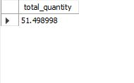

**#Which country received the highest quantity of exports in 2015 -2016?**

elect country_name , sum(quantity) as total_quantity

from pc_export_2015_2016

group by country_name

order by total_quantity desc

limit 1;

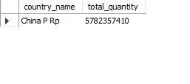

**#What was the total import value to Uganda in 2016-2017?**

select country_name ,sum(value)

from pc_import_2016_2017

group by country_name

having country_name = 'Kenya';

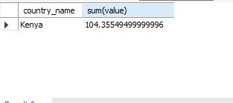

**#How many different countries are included in the export data set?**

select count(distinct(country_name))

from uniontable2;



**#How many different countries are included in the import data set?**

create view uniontable3 as

select * from

pc_import_2014_2015

Union all

select * from

pc_import_2015_2016;

create view uniontable4 as

select * from

uniontable3

Union all

select * from

pc_import_2016_2017;

select * from uniontable4;

select count(distinct(country_name))

from uniontable4;



**#Which year had the highest total export value?**

SELECT

MAX(total_export_value) AS highest_export_value

FROM

(SELECT

'2014_2015' AS year,

SUM(value) AS total_export_value

FROM

pc_export_2014_2015

UNION ALL

SELECT

'2015_2016' AS year,

SUM(value) AS total_export_value

FROM

pc_export_2015_2016

UNION ALL

SELECT

'2016_2017' AS year,

SUM(value) AS total_export_value

FROM

pc_export_2016_2017) AS yearly_exports;

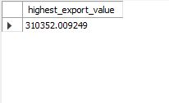

**#Which year had the highest total import value?**

SELECT

MAX(total_import_value) AS highest_import_value

FROM

(SELECT

'2014_2015' AS year,

SUM(value) AS total_import_value

FROM

pc_import_2014_2015

UNION ALL

SELECT

'2015_2016' AS year,

SUM(value) AS total_import_value

FROM

pc_import_2015_2016

UNION ALL

SELECT

'2016_2017' AS year,

SUM(value) AS total_import_value

FROM

pc_import_2016_2017) AS yearly_imports;

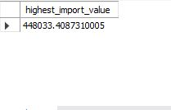

**#What was the average quantity of exports 2014-2015 to Tanzania Rep?**

SELECT

country_name, AVG(quantity)

FROM

pc_export_2014_2015

GROUP BY country_name

HAVING country_name = 'Tanzania Rep';

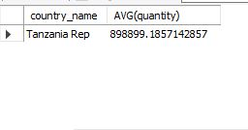

**# Which country had the lowest import value in 2014?**

SELECT

country_name, SUM(value) AS total_imports

FROM

pc_import_2014_2015

GROUP BY country_name

ORDER BY total_imports ASC

LIMIT 1;



**#What is the percentage change in export value to Benin from 2014 to 2017?**

SELECT

((export_2017 - export_2014) / export_2014) * 100 AS percentage_change

FROM

(SELECT

SUM(value) AS export_2014

FROM

pc_export_2014_2015

WHERE

country_name = 'Benin') AS benin_2014,

(SELECT

SUM(value) AS export_2017

FROM

pc_export_2016_2017

WHERE

country_name = 'Benin') AS benin_2017;

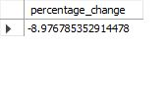

**#Is there any country that received zero exports throughout the entire period?**

select * from uniontable2

where value = 0;

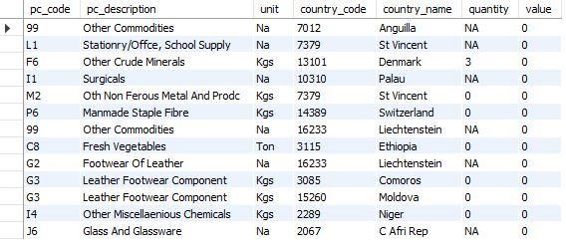

**#Which country had the highest average export value ?**

SELECT

country_name, SUM(value) AS total_export

FROM

uniontable2

WHERE

value > (SELECT

AVG(value)

FROM

uniontable2)

GROUP BY country_name

ORDER BY total_export DESC

Limit 1;



**# What is the total export value of "Other Commodities" across all countries and years?**

SELECT

pc_code, SUM(value) AS total_export

FROM

uniontable2

WHERE

pc_description = 'Other Commodities'

GROUP BY pc_code;

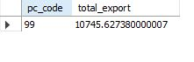

**-- Identify the country with the highest import value in 2017.**

SELECT

country_name, SUM(value) AS total_import

FROM

pc_import_2016_2017

GROUP BY country_name

ORDER BY total_import DESC

limit 1;

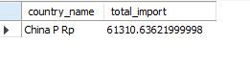

**#How much value of "Other Commodities" were imported to Unspecified countries in 2016?**

SELECT

pc_code, SUM(value) AS total_import

FROM

pc_import_2015_2016

WHERE

pc_description = 'Other Commodities'

GROUP BY pc_code

ORDER BY total_import;

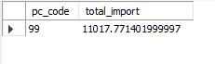

**#What is the average export value for all countries and years?**

SELECT

AVG(value) avg_export

FROM

uniontable2;



**#Which country had the lowest export in 2015?**

SELECT

country_name, SUM(value) AS total_export

FROM

pc_export_2015_2016

GROUP BY country_name

ORDER BY total_export ASC

LIMIT 1;



**-- Identify the country with the highest exports in 2014.**

SELECT

country_name, SUM(value) AS highest_exports

FROM

pc_export_2014_2015

GROUP BY country_name

ORDER BY highest_exports DESC

LIMIT 1;



**#Calculate the total export value to all specified countries (excluding "Unspecified") in 2017.**

SELECT

country_name, SUM(value) AS total_export_value

FROM

pc_export_2016_2017

;

